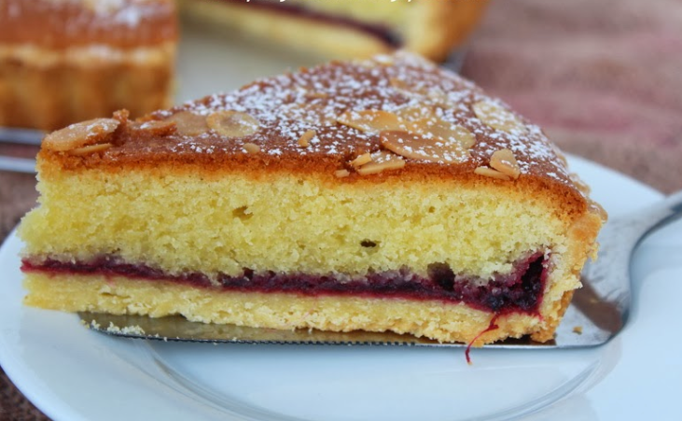

**Almond Tart**  Makes 12 individual tarts or one 18cm tart.

**Pastry**

50g butter or block margarine

100g plain flour

pinch salt

3 to 4 tablespoons cold water

In a large bowl rub the butter into the flour and salt using the tips of your fingertips.

When the mixture resembles breadcrumbs use a round ended knife to stir in the water a little at a time.

Use your hands to bring the pastry together into a ball, wrap in cling film and rest in the fridge for 30 minutes, if possible.

Take the rested pastry from the fridge and roll out to 3-4mm thick.

Cut out 8cm rounds and line bun tins, or gently fold in the corners to the middle and carefully place in a 18cm flan tin. Trim the edges.

**Filling**

4 tablespoons of jam

75g sugar

75g butter or block margarine

50g semolina

75g SR flour

½ teaspoon almond essence

1 egg

2 tablespoons milk

Icing sugar (optional)

Preheat the oven to 180C, Gas 4.

Spread jam on the centre of the pastry.

In a medium bowl cream sugar and butter together until soft.

Add remaining ingredients and beat well. Add more milk if necessary to get a slightly soft mixture.

Carefully spoon onto the jam, spreading to the edges of the pastry case (to seal in the jam.)

Bake for 20 minutes until golden brown. Dust with icing sugar before serving.