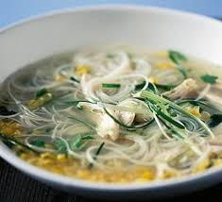

Chicken Noodle Soup
1.5l chicken or vegetable stock
2 boneless, skinless chicken breasts (about 350g)
2 teaspoons of fresh root ginger
1 garlic clove
100g fine rice or wheat noodles
4 tablespoons sweetcorn, canned or frozen
5-6 mushrooms
4 spring onions
4 teaspoons pf soy sauce, plus a little extra for serving

Finely chop the ginger and garlic.
Roughly cut the chicken breasts into 4 quarters (to make cooking quicker.)
Pour the stock into a pan and add the chicken, ginger and garlic.
Bring to the boil, then reduce the heat, partly cover and simmer for 15 mins, or until the chicken is tender.
Meanwhile, slice the mushrooms and spring onions very thinly.
Remove the chicken to a board and shred into small bite-size pieces using a couple of forks.
Return the chicken to the stock with the noodles, sweetcorn, mushrooms, half the spring onions and the soy sauce. AS the soup comes to a simmer stir the noodles to keep them separate. Then continue to simmer for 3-4 mins until the noodles are tender.
Scatter over the remaining spring onions, and serve with extra soy sauce for sprinkling.

