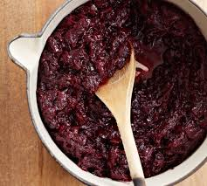

Beetroot, apple and orange relish
1 tablespoon oil
2 small onions
1 teaspoon ground allspice
½ teaspoon ground cinnamon
2 medium cooked fresh beetroot
2 sharp apples
1 large orange
200g brown sugar
Pinch salt
125ml balsamic or red wine vinegar
Peel and finely chop the onions. Heat the oil in a medium saucepan and fry the onions and spices over a gentle heat for 4-5 minutes.
Grate the beetroot and apples (no need to peel). Grate the zest (outer orange part of the skin) from the orange.
Add the beetroot, apple, orange zest, sugar, salt and vinegar to the saucepan.
Bring to the boil stirring continuously. Lower the heat and simmer uncovered for 20 minutes, stirring occasionally. If the relish becomes too dry add a splash more vinegar.
Serve hot or cold with cooked meats.
Top Tip for adults:
This has a ‘christmassy’ flavour and would be especially good with cold turkey or ham.
To keep until Christmas:
Place a large empty jam jar in a preheated oven to Gas ¼ , 110C, for 20 minutes. Wash the lid in hot soapy water and rinse with boiling water. Fill the jar with relish while both are still hot. Firmly screw the lid on. Once cooled, this will keep in the fridge for up to 2 months.

