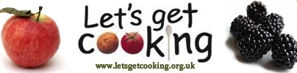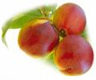 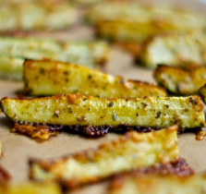

**Courgette Chips**

Serves 4

1 egg white

300g courgette

1/2 teaspoon paprika

1/2 teaspoon any other dried herb to your taste (optional)

 a pinch salt

Heat oven to 200C, Gas 6.

Line a large baking tray with baking parchment or greaseproof paper.

Wash the courgettes and trim off the ends.

Cut across the middle to give 2 even lengths.

Then cut each length into roughly rectangular 'chips', although they will have a curved side where the skin is!

Whisk egg white in a bowl until bubbly.

Mix the herbs and salt together, on a small plate.

Dip the 'chips' in the egg white, then the herb mixture, then lay on the prepared baking tray.

Bake for 10-15 minutes until lightly browned and crispy.