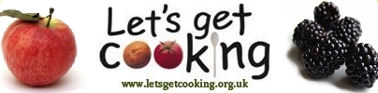 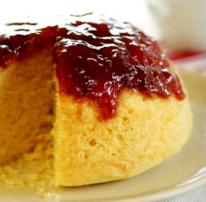

**Just a Sponge?**

**Basic Sponge Pudding**

50g soft margarine

50g caster sugar

1 egg

Few drops vanilla essence

100g SR flour

3 tblsp milk

First choose the flavourings from the **Flavour Varieties** section (overleaf) to add to your mixture or your cooking dish/bowl/mug. Then choose how you will cook your pudding from the **Pudding Varieties** section (also overleaf.)

Put all ingredients together in a bowl and beat until smooth.

If the mixture does not drop off the spoon in a soft blob (soft dropping consistency), beat in another tablespoon of milk.

**Flavour Varieties**

Essex pudding – spread jam over sides and base of greased 1 pint basin.

Various tinned fruit sponge pudding – Drain 411g can of fruit and arrange over base of greased basin.

Syrup sponge pudding - Put 2 tblsp syrup into base of greased basin.

Lemon or orange sponge pudding – add grated zest of an orange or lemon to the basic mixture.

Jamaica sponge pudding – add 50g-100g chopped stem ginger to the basic mixture.

Chocolate sponge pudding – blend 4 level tblsp cocoa powder with 1 tblsp hot water. Add just 2 tablespoons of the milk from the basic recipe at first. Add remaining milk if needed.

**Pudding Varieties**

Family Sponge Pudding

Spoon mixture into a greased 1 pint pudding basin. Microwave on low for 7-9 minutes – until top of pudding is only slightly moist. Leave for 5 minutes before turning out.

Individual sponge puddings (makes 3)

Spoon mixture into a 3 medium sized, greased mugs. Microwave for 3 minutes, until risen and set.

Upside-Down-Pudding

Heat oven to 180°C, 350°F, gas mark 4. Place slices of fresh or canned fruit in the base of a greased tin or dish. Spoon over 1 tablespoon of golden syrup. Spoon mixture on top and gently level. Bake for 15-20 minutes.

Place a plate over the pudding then turn upside down so pudding slides out onto the plate.

 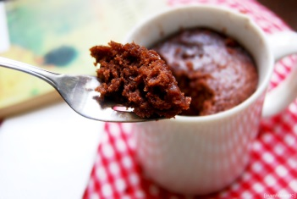

**5 MINUTE CHOCOLATE CAKE**

4 tablespoons self-raising flour

4 tablespoons sugar

1 tablespoon cocoa

1 egg

3 tablespoons milk

3 tablespoons oil

3 tablespoons chocolate chips (optional)

a small splash of vanilla extract

1 large mug

Add the dry ingredients (flour, sugar and cocoa) to the mug, and mix well.

Add the egg and mix thoroughly.

Pour in the milk and oil and mix well.

Add the chocolate chips (if using) and vanilla extract, and mix again.

 Put your mug in the microwave and cook for 3 minutes at 1000 watts (high). The cake will rise up and maybe over the top of the mug, but don't be alarmed!

Allow to cool a little, and tip out onto a plate if desired, or eat straight from the mug!